* ***Broadcast Receivers***

***Broadcast Receivers****simply respond to broadcast messages from other applications or from the system itself. These messages are sometime called events or intents. For example, applications can also initiate broadcasts to let other applications know that some data has been downloaded to the device and is available for them to use, so this is broadcast receiver who will intercept this communication and will initiate appropriate action.*

There are following two important steps to make BroadcastReceiver works for the system broadcasted intents −

* Creating the Broadcast Receiver.
* Registering Broadcast Receiver

There is one additional steps in case you are going to implement your custom intents then you will have to create and broadcast those intents.

Creating the Broadcast Receiver

A broadcast receiver is implemented as a subclass of **BroadcastReceiver** class and overriding the onReceive() method where each message is received as a **Intent** object parameter.

public class MyReceiver extends BroadcastReceiver {

@Override

public void onReceive(Context context, Intent intent) {

Toast.makeText(context, "Intent Detected.", Toast.LENGTH_LONG).show();

}

}

Registering Broadcast Receiver

An application listens for specific broadcast intents by registering a broadcast receiver in *AndroidManifest.xml* file. Consider we are going to register *MyReceiver* for system generated event ACTION_BOOT_COMPLETED which is fired by the system once the Android system has completed the boot process.

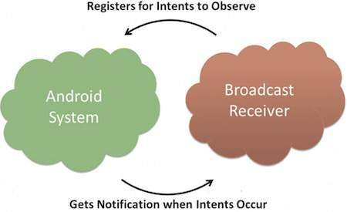

Broadcast-Receiver

<application

android:icon="@drawable/ic_launcher"

android:label="@string/app_name"

android:theme="@style/AppTheme" >

<receiver android:name="MyReceiver">

<intent-filter>

<action android:name="android.intent.action.BOOT_COMPLETED">

</action>

</intent-filter>

</receiver>

</application>

Now whenever your Android device gets booted, it will be intercepted by BroadcastReceiver *MyReceiver* and implemented logic inside *onReceive()* will be executed.

There are several system generated events defined as final static fields in the **Intent** class. The following table lists a few important system events.

|  |  |
| --- | --- |
| **Sr.No** | **Event Constant & Description** |
| 1 | **android.intent.action.BATTERY_CHANGED**  Sticky broadcast containing the charging state, level, and other information about the battery. |
| 2 | **android.intent.action.BATTERY_LOW**  Indicates low battery condition on the device. |
| 3 | **android.intent.action.BATTERY_OKAY**  Indicates the battery is now okay after being low. |
| 4 | **android.intent.action.BOOT_COMPLETED**  This is broadcast once, after the system has finished booting. |
| 5 | **android.intent.action.BUG_REPORT**  Show activity for reporting a bug. |
| 6 | **android.intent.action.CALL**  Perform a call to someone specified by the data. |
| 7 | **android.intent.action.CALL_BUTTON**  The user pressed the "call" button to go to the dialer or other appropriate UI for placing a call. |
| 8 | **android.intent.action.DATE_CHANGED**  The date has changed. |
| 9 | **android.intent.action.REBOOT**  Have the device reboot. |